***Press Release***

*Sindelfingen, 22. October 2024*

**New Tool Support at EuroBLECH**Maximum ergonomics for machine operators

**At EuroBLECH in Hanover, RAS Reinhardt Maschinenbau GmbH sets new standards in ergonomics and work facilitation with the introduction of the new Tool Support. This optional system, available for both the RAS XLTbend and RAS MEGAbend machines, significantly simplifies the handling of upper beam tools used in the production of large box heights.**

The Tool Support allows for the effortless handling of upper beam tools up to 300 mm (XLTbend) and 400 mm (MEGAbend), designed to accommodate large box heights. Even at this “box height”, RAS tools of this type still allow exceptional sheet thicknesses and are dimensioned accordingly.

This system enables tools to be moved to the desired position or stored in the machine’s integrated tool magazine not only ergonomically, but also nearly "weight-neutrally."

**Ergonomics at the forefront**The Tool Support represents a significant advancement in workplace ergonomics. It allows operators to move large and heavy tools without physical effort. By minimizing the required effort, the operator's workload is significantly reduced, enhancing overall comfort. In addition, this reduces fatigue and importantly lowers the risk of injury from repetitive heavy lifting.

With the Tool Support, RAS Reinhardt Maschinenbau GmbH provides a solution that promotes both healthier working conditions and greater efficiency, leading to improved productivity and enhanced well-being.

(1408 Characters incl. spaces)

**About RAS:**

RAS Reinhardt Maschinenbau GmbH is the world's leading manufacturer of innovative machines for sheet metal processing. Headquartered in Sindelfingen, the company has been renowned for over 85 years for its exceptional quality and technical precision, proudly representing "Made in Germany.". The extensive portfolio includes folding machines, swing beam shears, forming machines, as well as automated and customized manufacturing solutions for various industries worldwide. With a strong focus on quality, reliability, and technological innovation, RAS delivers solutions that meet the highest demands.

(603 Characters incl. spaces)

**Download-Area:**www.ras-online.de/en/news/press/

**Deep links:**www.ras-online.de/en/products/bending/megabend/  
www.ras-online.de/en/products/bending/xltbend/  
www.ras-online.de/

**Images:**

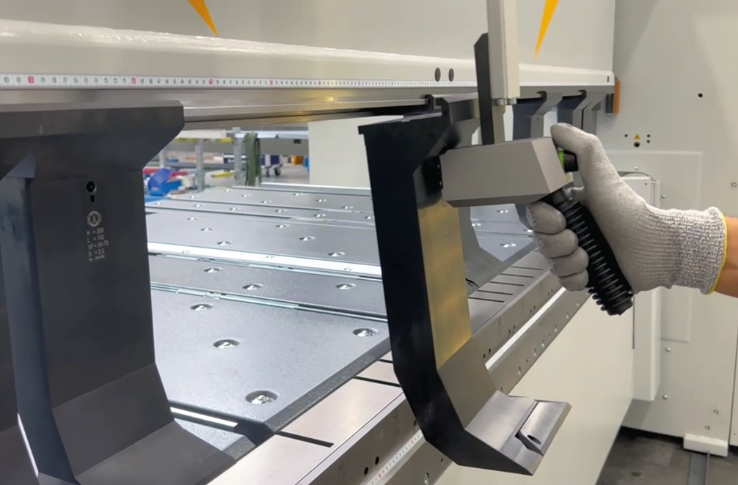

**ToolSupport_Werkzeug.jpg:** The Tool Support simplifies the handling of large tools and improves working conditions.  
Source: RAS Reinhardt Maschinenbau GmbH

**Contact:**

**For the readers:**

**RAS Reinhardt Maschinenbau GmbH**

Richard-Wagner-Str. 4-10

71065 Sindelfingen

Deutschland

+49-7031-863-0

info@RAS-online.de

www.RAS-online.de

**Press contact**

Romina Klingler  
Marketing Managerin  
klr@ras-online.de  
+49-7031-863-171

RAS Reinhardt Maschinenbau GmbH

Richard-Wagner-Str. 4-10

71065 Sindelfingen