***Press Release***

*Sindelfingen, 05.08.2025*

**High performance in a compact space: the new TURBO2plus Compact**RAS introduces the compact successor to its proven bending machine

**With the new TURBO2plus Compact, RAS Reinhardt Maschinenbau modernizes its machine portfolio with a space-saving bending solution that delivers maximum precision and flexibility, even in confined production environments. The machine is specifically designed for small businesses that cannot afford to compromise on quality, bending capacity, or ease of use despite limited installation space.**

The TURBO2plus Compact is based on the construction and technology of the standard TURBO2plus model, but features a newly designed housing. Thanks to its more compact build, and in particular the reduced overall height, the machine integrates easily even into tight spaces. Improved access to the machine also simplifies the handling of larger parts and enhances material flow. It is available in bending lengths of 2540 mm, 3200 mm, or 4060 mm, and can process steel sheets up to 2.5 mm thick with a tool height of 145 mm.

**Flexible control options**The control system of the compact version offers maximum flexibility. Depending on user preference, the machine can be operated with either the intelligent, graphically guided Bendex software or the streamlined OpenEditor interface. Both options ensure fast, precise, and efficient programming.

**Modular and versatile**Like the TURBO2plus, the compact model is ideal for use in sheet metal shops, roofing and façade applications, sign manufacturing, and general metalworking environments. It can be flexibly equipped with segmented upper beam tools for creating three- or four-sided bent parts, such as boxes. Segmented folding beam tools or crowning rails can also be integrated to achieve special geometries and high precision, even on long parts.

The TURBO2plus Compact delivers the same technical capabilities and process reliability as the previous standard model, while requiring significantly less space.

(1.847 Characters incl. spaces)

**About RAS:**

RAS Reinhardt Maschinenbau GmbH is the world's leading manufacturer of innovative machines for sheet metal processing. Headquartered in Sindelfingen, the company has been renowned for over 85 years for its exceptional quality and technical precision, proudly representing "Made in Germany". The extensive portfolio includes folding machines, swing beam shears, forming machines, as well as automated and customized manufacturing solutions for various industries worldwide. With a strong focus on quality, reliability, and technological innovation, RAS delivers solutions that meet the highest demands.

(602 Characters incl. spaces)

**Deep links:**

www.ras-online.de   
www.ras-online.de/en/products/bending/turbo2plus-compact/

**Download-Area**

www.ras-online.de/en/press/

**Images:**

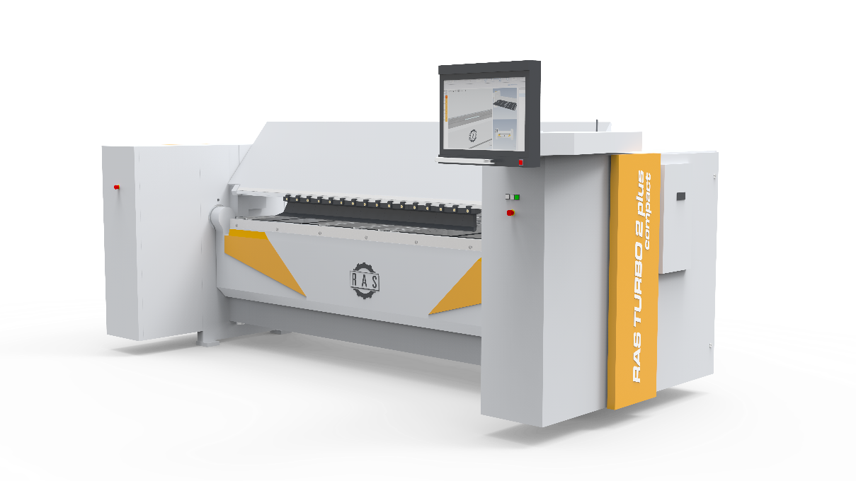

**TURBO2plus compact.jpg:** The new TURBO2plus Compact: now with a space-saving design for small businesses with limited space  
Source: RAS Reinhardt Maschinenbau GmbH

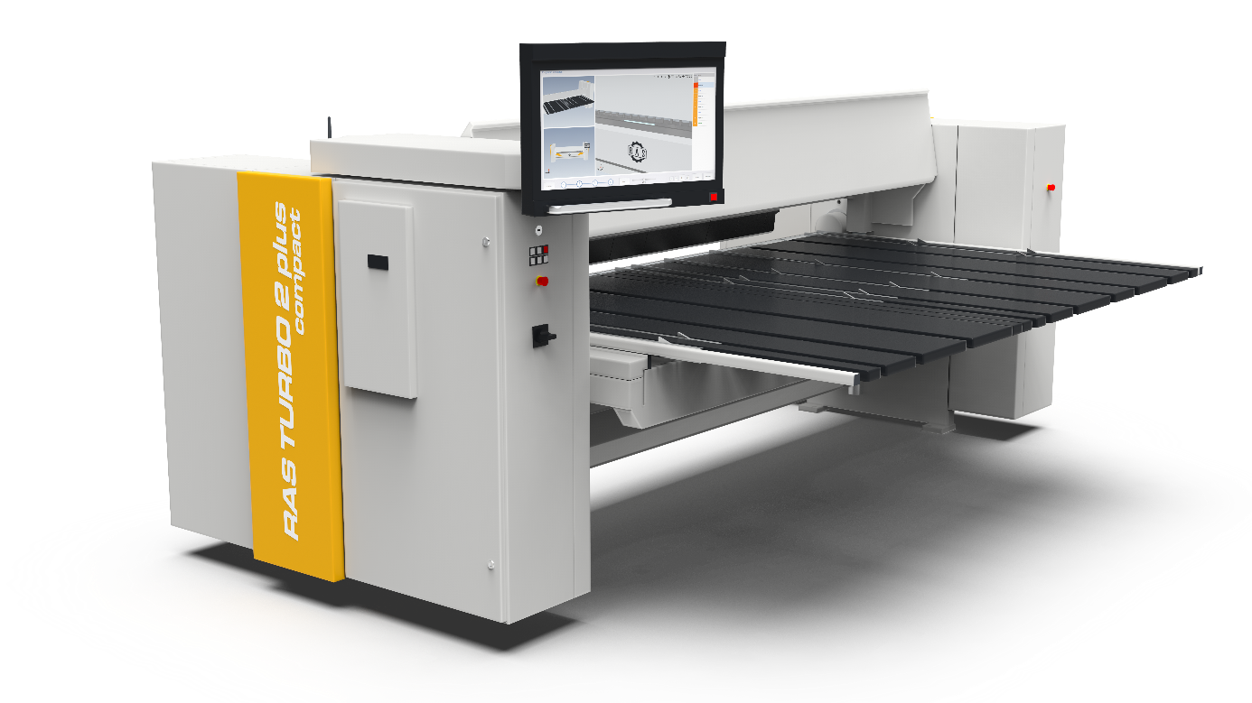

**TURBO2plus Daten.jpg:** Same technology as the previous TURBO2plus - bending lengths up to 4060 mm, sheet thicknesses up to 2.5 mm.  
Source: RAS Reinhardt Maschinenbau GmbH

**Contact:**

**RAS Reinhardt Maschinenbau GmbH**

Richard-Wagner-Str. 4-10

71065 Sindelfingen

Deutschland

+49-7031-863-0

Sales@RAS-online.de

[www.RAS-online.de](http://www.RAS-online.de)

**Press contact:**

Romina Klingler  
Marketing Managerin  
klr@ras-online.de  
+49-7031-863-171

RAS Reinhardt Maschinenbau GmbH

Richard-Wagner-Str. 4-10

71065 Sindelfingen