Press release

Sindelfingen, February 24, 2026

TURBO2plus Compact with new XXL folding beam
Additional free space behind the bending line for complex part geometries
With the TURBO2plus Compact, RAS Reinhardt Maschinenbau enhances its proven folding machine with a key advancement: the new XXL folding beam. The compact machine is designed for roofing, façade and sheet metal applications, combining high bending performance with a space-saving solution.
Developed as a compact solution for workshops with limited floor space, the TURBO2plus Compact is available in bending lengths of 2,540 mm, 3,200 mm or 4,060 mm. It is ideally suited for roofing and facade cladding, sign making and general sheet metal fabrication.
XXL folding beam for additional flexibility
The new XXL folding beam provides extended free space of up to 5 mm behind the bending line, allowing increased flexibility when forming complex part geometries. In this configuration, sheet thicknesses of up to 2.0 mm can be processed.
The system is complemented by the 14 mm Crown Tool with adjustable crowning, ensuring consistent and high-quality bending results across the entire working length. Users benefit from improved precision and process reliability, particularly when producing roof flashings, facade elements and window profiles
With the TURBO2plus Compact, RAS offers a powerful and flexible solution for precise bending operations in the sheet metal industry, delivering proven performance within a compact machine design.
(1.334 Characters incl. spaces, 199 words)

About RAS:
RAS Reinhardt Maschinenbau GmbH is the world's leading manufacturer of innovative machines for sheet metal processing. Headquartered in Sindelfingen, the company has been renowned for over 85 years for its exceptional quality and technical precision, proudly representing "Made in Germany". The extensive portfolio includes folding machines, swing beam shears, forming machines, as well as automated and customized manufacturing solutions for various industries worldwide. With a strong focus on quality, reliability, and technological innovation, RAS delivers solutions that meet the highest demands.
(602 Characters incl. spaces, 81 words)

Deeplinks:
www.ras-online.de
www.ras-online.de/en/products/bending/turbo2plus-compact/

Download-Area
https://www.ras-online.de/en/press/

Images
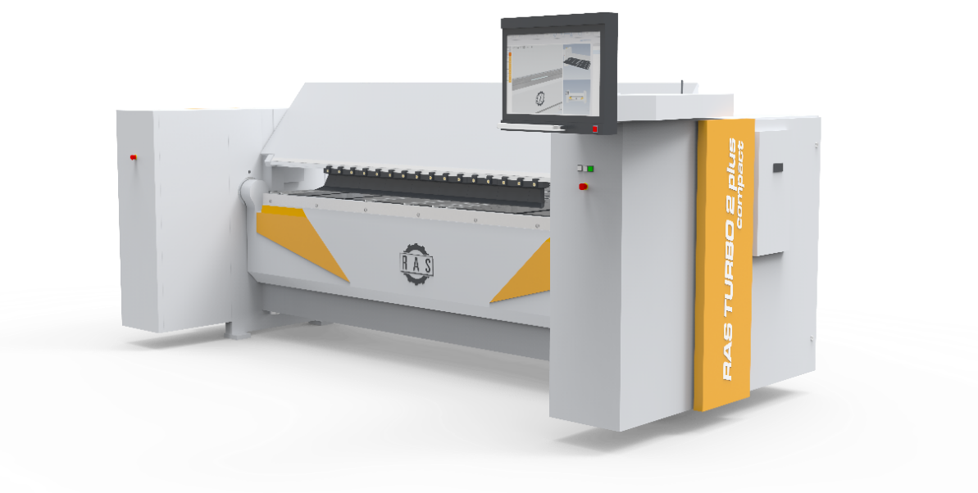
TURBO2plus compact.jpg: Compact folding machine with new XXL folding beam and 14 mm Crown Tool with adjustable crowning.
Source: RAS Reinhardt Maschinenbau GmbH

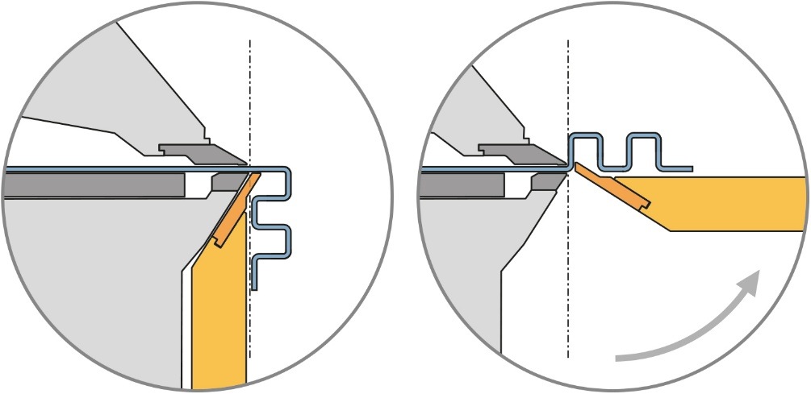
XXL-Biegewange.jpg: The extended free space of 5 mm behind the bending line provides additional flexibility for complex part geometries.
Source: RAS Reinhardt Maschinenbau GmbH

Contact:

RAS Reinhardt Maschinenbau GmbH
Richard-Wagner-Str. 4-10
71065 Sindelfingen
Deutschland

+49-7031-863-0
Sales@RAS-online.de
www.ras-online.de

Press contact:
Romina Klingler
Marketing Managerin
klr@ras-online.de
+49-7031-863-171
RAS Reinhardt Maschinenbau GmbH
Richard-Wagner-Str. 4-10
71065 Sindelfingen

