Press release
Sindelfingen, 3 March 2026
PRIMEcut now also available in 4 meters
Precise cutting for large-format sheet metal in roofing and facade construction
With the revised PRIMEcut 53.40-3, RAS Reinhardt Maschinenbau expands its shear range with a version offering a working length of 4,150 mm. The company is responding to the growing demand for precise and surface-protecting cuts, particularly in roofing and facade construction as well as in general sheet metal fabrication.
The machine operates with advanced swing beam cutting technology, enabling dimensionally accurate blanks and exceptionally straight cutting edges. The low cutting angle ensures torsion-free results, even when processing sensitive materials. Long blade service life further enhances cost-efficiency in daily operation.
Cut parts can be sorted during the cutting process, either to the front or to the rear. An integrated sheet support system improves material flow and reduces manpower requirements during handling. In the new 4-meter version, sheet thicknesses of up to 2.0 mm can be cut safely.
New features for enhanced operating comfort and surface protection
The updated PRIMEcut incorporates several new details that improve safety and quality. These include brighter LED cutting area lighting with integrated finger protection, ensuring optimal visibility in the cutting zone, as well as a pop-up hold-down system. The pop-up hold-down system enables particularly surface-friendly processing and reduces pressure marks on sensitive materials.
A new squaring arm with digital display enables quick and easy measurement reading. Additional flexibility is ensured by laterally adjustable table elements with a height adjusted of 3 mm, allowing adaptation to various application requirements.
With the 4-meter PRIMEcut, RAS offers a powerful solution for users seeking high cutting quality, ergonomic operation and efficient production processes.
(1.768 Characters incl. spaces, 253 words)

About RAS:
RAS Reinhardt Maschinenbau GmbH is the world's leading manufacturer of innovative machines for sheet metal processing. Headquartered in Sindelfingen, the company has been renowned for over 85 years for its exceptional quality and technical precision, proudly representing "Made in Germany". The extensive portfolio includes folding machines, swing beam shears, forming machines, as well as automated and customized manufacturing solutions for various industries worldwide. With a strong focus on quality, reliability, and technological innovation, RAS delivers solutions that meet the highest demands.
(602 Characters incl. spaces, 81 words)

Deeplinks:
www.ras-online.de/
www.ras-online.de/en/schneiden/primecut/

Download-Area
https://www.ras-online.de/en/press/

Images
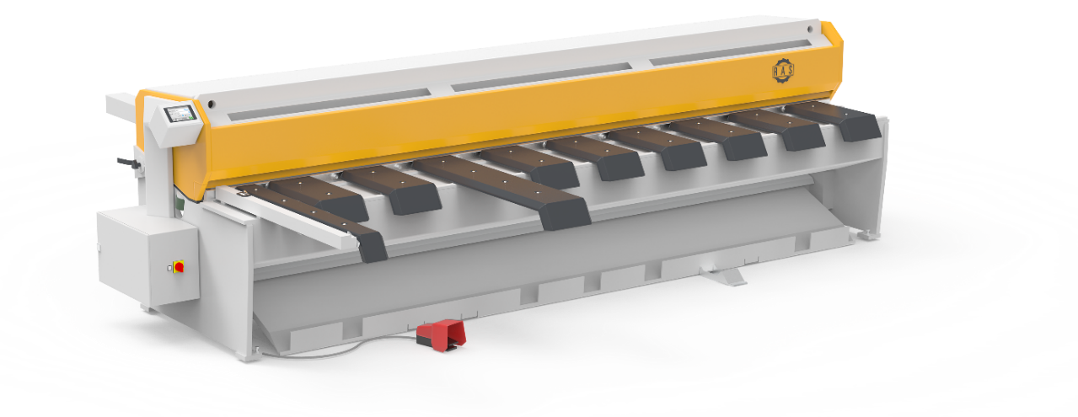
Bild: The RAS sheet metal shear now also available in a 4-meter version. Precise cutting results, surface-friendly processing and a pop-up hold-down system for fewer pressure marks.
Source: RAS Reinhardt Maschinenbau GmbH

Contact:

RAS Reinhardt Maschinenbau GmbH
Richard-Wagner-Str. 4-10
71065 Sindelfingen
Deutschland

+49-7031-863-0
Sales@RAS-online.de
www.ras-online.de

Press contact:
Romina Klingler
Marketing Managerin
klr@ras-online.de
+49-7031-863-171
RAS Reinhardt Maschinenbau GmbH
Richard-Wagner-Str. 4-10
71065 Sindelfingen

